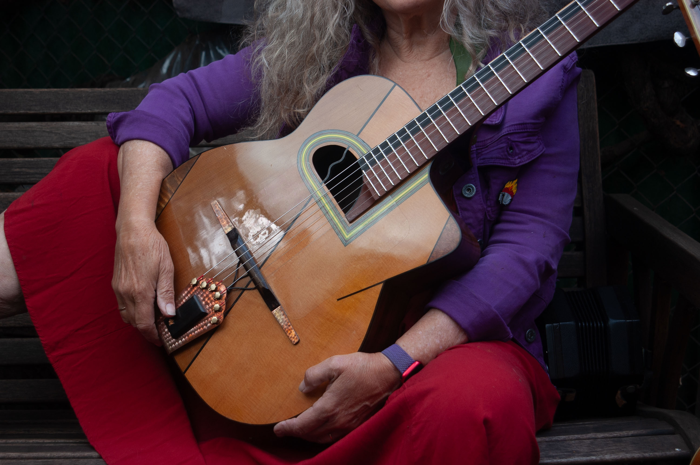
KristinaOlsen.net
Sydney Morning Herald: Olsen, an itinerant troubadour who regularly graces Australian folk festivals, was at her most engaging. Such was the candour of her songs and chatty tales that it would impossible for anyone with blood in their veins not to empathise with her. Her full-throated voice and crisp guitar served up such diverse subject matter as crop-dusting and prostitution, while a revealing yarn about life-drawing classes introduced The Truth of a Woman. From her new CD came In Your Darkened Room, the title track to an album containing some of her finest work, a black frost edging her usual warmth and humour. John Shand

Christchurch Press, Christchurch, New Zealand: It is indeed a rare occurrence to be so completely captivated for an entire concert by one person and a guitar, but American singer/songwriter Kristina Olsen certainly managed this and more, delivering a highly entertaining show to a capacity audience for over two hours. From her opening songs I felt that this was a person I had known for much longer, the supreme accolade any storyteller can wish for. The audience of predominantly fortysongethings loved it, demanding that Olsen return to the stage for three encores. Patrick Shepherd.

Roots & Reel: To begin with the songs, they are those wonderful gems of song writing which don’t rely on any particular genre for their beginnings. Olsen builds melodies, not styles. She can wind them into unpredictable combinations which then become lovely melodies or she can deliver them in straight lines which become jazz- or blues-oriented pieces. Her guitar stylings are wide, ranging from delicate, complicated runs to aggressive direct blues runs. She’s a sharp guitarist, able to provide herself with both the rhythm and lead pieces she needs to give her songs solid solo support. As a storyteller, Olsen is similarly wonderful, mixing earthy observations about herself and those around with the occasional comment about society’s various shortcomings. Most of all, though, Olsen is funny, noting those things which innocently point out where she and all of us provide material for comic relief. She’s talented, funny, and observant, and consequently she becomes the witty friend who shares her life with you, not preaching to you or insisting on our praise to maintain the friendship.

Los Angeles Times: Olsen is an eclectic artist worthy of much more acclaim.

Acoustic Musician: Strong songs and guitar playing, great singing and intimate stories... after hearing it I’m in love with the lady.

Folk Almanac: This is Olsen playing solo to the world, and the results are stunning...playing slide guitar with a fury, finely crafted songs, personal and delivered with fire...

Boston Herald: ..wicked blues slide guitar...soon her storytelling becomes so wonderful, and her music so expressive, one realized that the untamed Olsen is more valuable than any slicker version could be.
KRISTINA OLSEN bio:

Kristina Olsen born in San Francisco, California, and is now living in Burnaby, BC, Canada. She is one of the most entertaining and compelling performers on the international acoustic circuit. A superb multi-instrumentalist (acoustic guitar, steel-body slide guitar, saxophone, concertina, banjo, mandolin and piano) as well as an award-winning songwriter with a big bluesy voice, Olsen has audiences around the world coming back for more. Her mix of powerful songs ranging from sassy bottleneck blues to lilting ballads to swing jazz to raunch and roll (as well as her hilarious storytelling) makes for a diverse and satisfying musical experience, on stage, on disc and in book.

Olsen has released thirteen recordings (four on the Philo/Rounder label), a live DVD and an enhanced eBook with music, (They Paid Us in Tub Time). She has collaborated with musicians all over the world, touring with Jez Lowe and James Keelaghan in theThree Nations Tour, creating an album of co-writes with with Canadian jazz guitarist/composer Bill Coon and she has been long time collaborator with Australian cellist Peter Grayling. She has entered a brave new world, neither jazz nor blues nor singer-songwriter. Art music at its best without conforming to expected genres. Fresh, weird, beautiful and familiar all at the same time. Her newest project is developing chorale arrangements of her songs to bring local choirs to her gigs to join her on some selected songs.

Olsen’s songs have been covered by such respected artists as; Eric Bibb, Fairport Convention, Maddy Prior, Mary Coughlan and Mollie O’Brien. Olsen has also worked as a session musician on numerous artist’s albums including playing the hammered dulcimer on Michelle Shocked’s album 'Short Sharp Shocked' on PolyGram and touring as Mary Coughlan’s guitarist in 2005. Her song “In Your Darkened Room” was used in the film “We’ll Always Have Dingle”, a documentary about an Irish Film Festival. Olsen has performed as a multi-instrumentalist in plays for the Mark Taper Forum in Los Angeles’ Music Center. Olsen won the Kerrville Song writing award her song for battered women, 'I'm Keeping This Life of Mine'

Olsen is a frequent contributor to Acoustic Guitar magazine, writing articles on guitar and performance technique. Olsen graduated from Berklee College of Music in 2020 with a dual major in guitar and orchestration/arranging.

Seasonal Suite of Chorales and Community Choir Connect Projects

The new Seasonal Suite of Chorales Project and Community Choir Connect Project is released for northern hemisphere winter’s solstice 2025 to 2026 (southern hemisphere coming winter 2026) and will involve interactive choirs being coached by Olsen via Zoom, then the choir will join her at the local venue. The idea was sparked when a local choir joined her at the National Folk Festival in Australia.

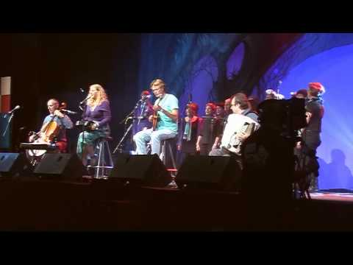
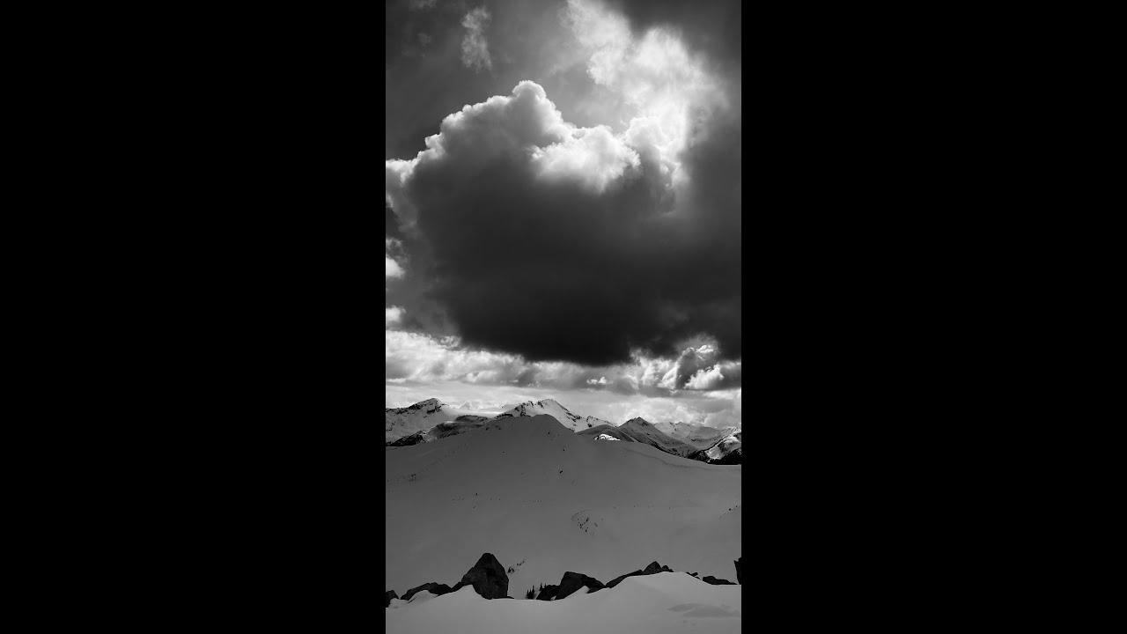
Here is that YouTube: And one from the Seasonal Suite of Chorales:

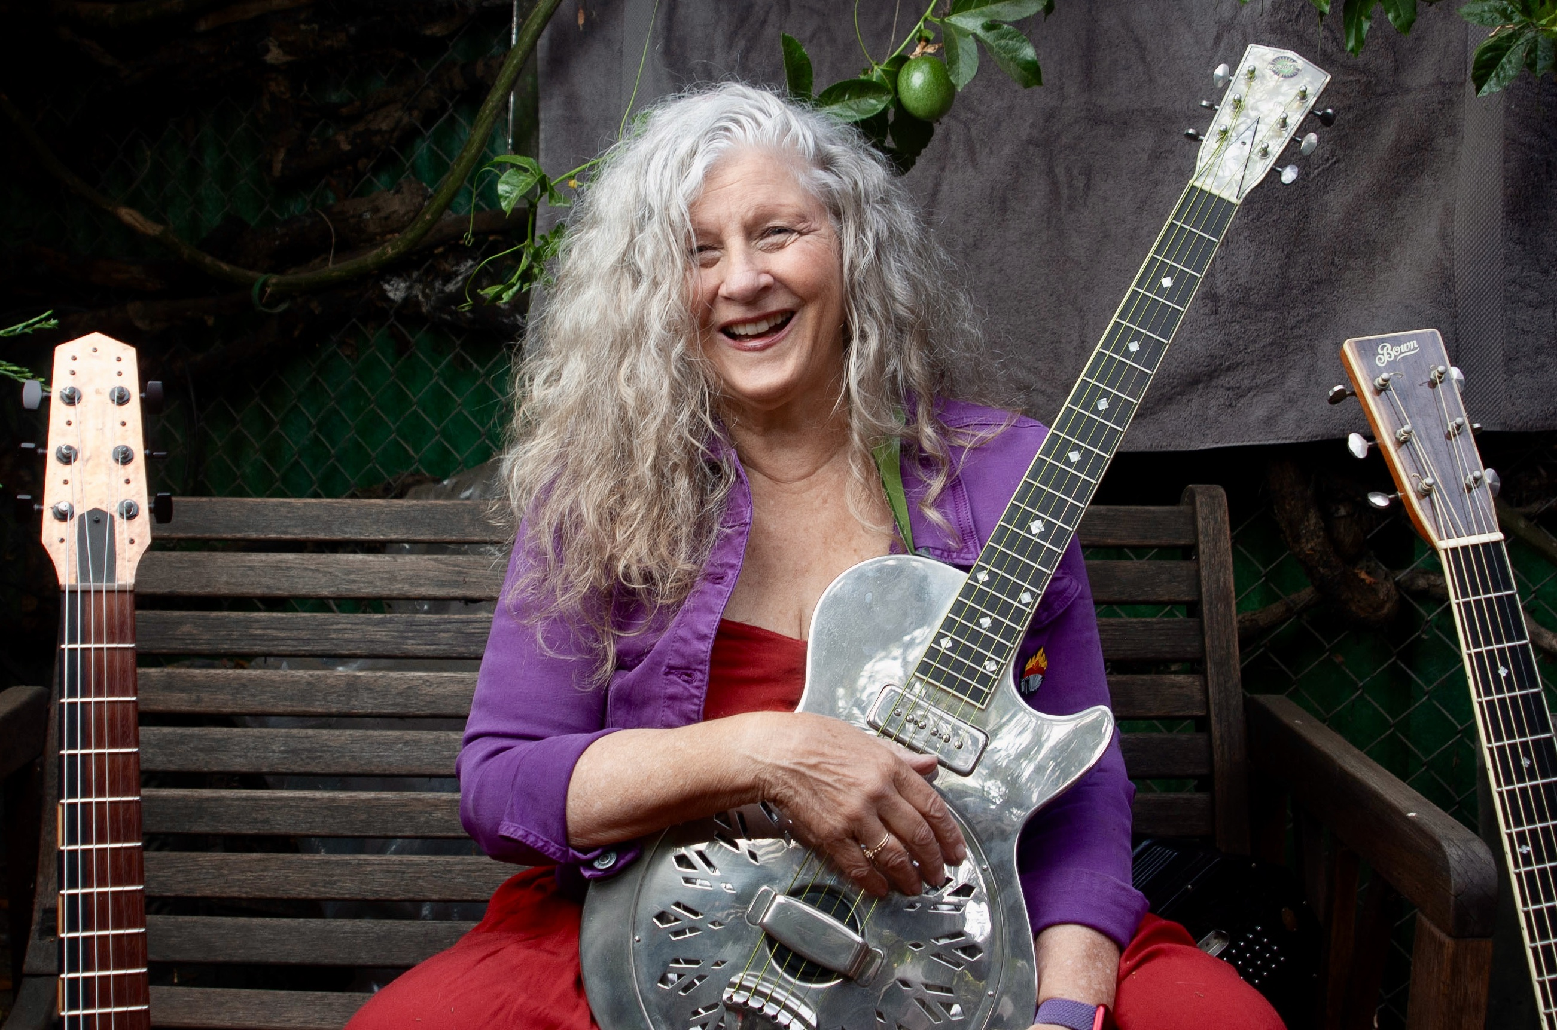
Other Kristina Olsen YouTube Links:

http://www.youtube.com/watch?v=jwaP4uSVKRo&feature=related (Something Tells Me)
http://www.youtube.com/watch?v=gwRFyv5yXrg (In Your Darkened Room)
http://www.youtube.com/watch?v=GAfIAqS1eNM&list=UUegblwxuT7ynhYlnqVQKa5A&index=1&feature=plcp (Cry You A Waterfall)
https://youtu.be/MZvmUFdPhGo (Air on the G String)
http://www.youtube.com/watch?v=GsBM43pQLHo&list=UUegblwxuT7ynhYlnqVQKa5A&index=2&feature=plcp (Dangerous)
https://youtu.be/jSm6v3uCBQM (I Still Do Miss You Pierre)
http://www.youtube.com/watch?v=3GeDOR8g9go (New Love)
http://www.youtube.com/watch?v=mvWKHr5Zv4o (Truth of a Woman)
http://www.youtube.com/watch?v=yDP_9EqE0Rc (How I Love This Tango)
http://www.youtube.com/watch?v=n1vNucD6x50&feature=related (joke)
http://www.youtube.com/watch?v=9nnvOJiOEr8 (Quiet Blue)
http://www.youtube.com/watch?v=nGdgG5fdlfw (The Yellow Piper)
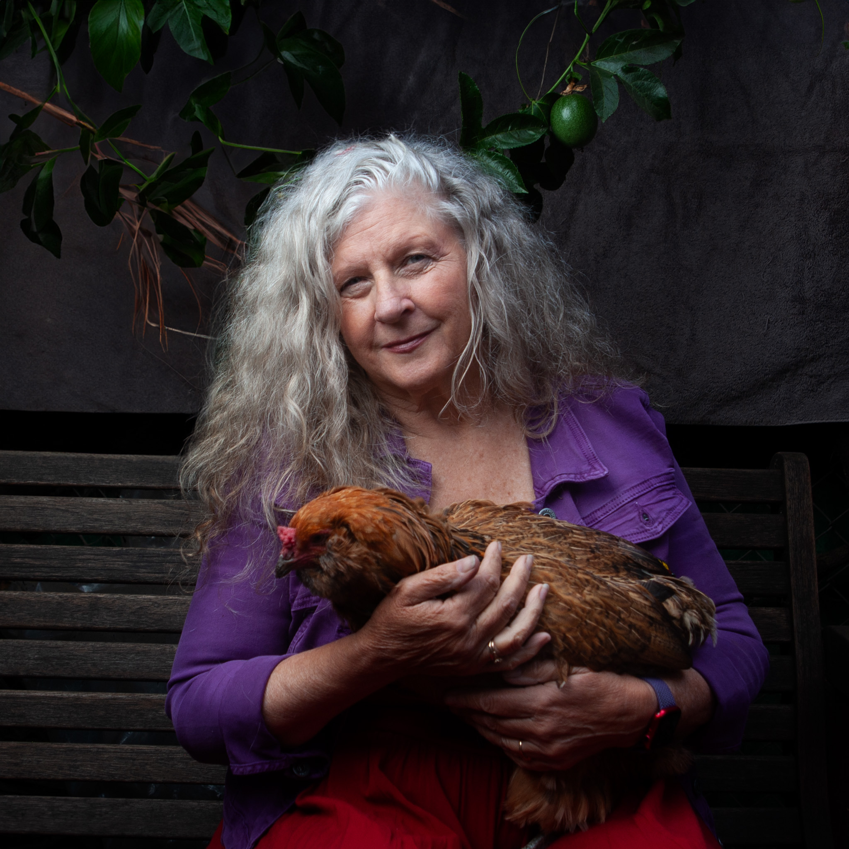
http://www.youtube.com/watch?v=HslwolCCD1Q&feature=related (Big O)

